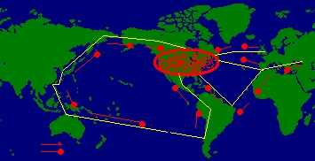
Weapon transport media to USA, Air defense system is not great ground defense system is great. When you can’t control illegal immigrants entering in to USA how you know what trash coming to USA?

What caused Iraq war: England and Israel
UK needs Oil to solve their oil problem. Israel needs Pipeline. Click below. Both countries misusing USA. Click below link.
http://www.atimes.com/atimes/Middle_East/ED04Ak01.html
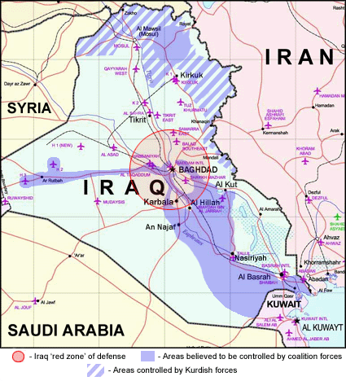

England (UK) need Oil not for USA click here:
Click following website link
UK needs Oil to solve their oil problem

http://news.bbc.co.uk/2/hi/in_depth/world/2000/world_fuel_crisis/
News on : Wednesday, 12 February, 2003, 19:04 GMT
Iraq war happen after Wednesday, 12 February, 2003, 19:04 GMT They calculated oil need or UK long back.
Anger at 'token' petrol cut -> | http://news.bbc.co.uk/2/hi/uk_news/1099070.stm
Oil prices surge into new year-> | http://news.bbc.co.uk/2/hi/business/1096916.stm
Fuel campaigners pause for thought -> | http://news.bbc.co.uk/2/hi/uk_news/1024624.stm
Fuel rally looks for support -> | http://news.bbc.co.uk/2/hi/uk_news/1017790.stm
Fuel protesters face exclusion zone -> | http://news.bbc.co.uk/2/hi/uk_news/1016421.stm
Blair: No more fuel concessions -> | http://news.bbc.co.uk/2/hi/uk_news/politics/1016633.stm
Fuel convoy legal threat-> | http://news.bbc.co.uk/2/hi/uk_news/scotland/1015129.stm
Brown's gifts fail to placate protesters-> | http://news.bbc.co.uk/2/hi/uk_news/politics/1014577.stm
In pictures: Fuel protest convoy sets off-> | http://news.bbc.co.uk/2/hi/uk_news/1016585.stm
The fuel protesters' story-> | http://news.bbc.co.uk/2/hi/uk_news/1009637.stm
Fuel protesters find the road can get rocky-> | http://news.bbc.co.uk/2/hi/uk_news/1011227.stm
The facts about low sulphur fuel-> | http://news.bbc.co.uk/2/hi/uk_news/1014912.stm
Desperate measures-> | http://news.bbc.co.uk/2/hi/uk_news/1016644.stm
Coping on empty-> | http://news.bbc.co.uk/2/hi/uk_news/politics/1003305.stm
Blair faces heavy price for fuel gamble -> | http://news.bbc.co.uk/2/hi/uk_news/politics/924748.stm
Oil companies: where to next? -> | http://news.bbc.co.uk/2/hi/business/926603.stm

England and Israel creating big problems
Hey USA, do you know England and Israel Plan: USA has army base all over world. England and Israel send Bunch of Nuke (with N. Korean script and write name Allah on Nukes) to USA to destroy USA. People run from USA to Europe mainly to England. So all money goes to England. So USA get destroy by Nuke. Before that USA throw Nuke on Gulf Countries. Muslims die in gulf countries. England comes to Gulf countries and act like serving to them. They take oil from them. USA army already there all over world, who will take care? England. Again starts colonization. All countries will be under control of England. Including USA. So who is genius? USA or England? Who is superpower USA or England? Now who is controlling world?, USA or England? You know who is misusing USA? When England and Israel used Middle East for Oil, pipeline and Muslims problems they can do any thing. Now terrorists are not after England and Israel, they are after USA.

Blair's bathroom gift to Bush revealed
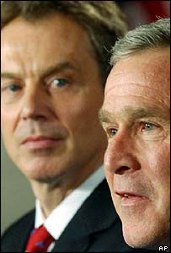
http://news.bbc.co.uk/2/hi/uk_news/politics/3066753.stm
Bathroom gift upset bush. No top leaders give such cheep gift to other top leader. That means insulting bush. That means Bush standing little or more against Blair. So for last 15 days. Bush asking India to put his Soldier in Iraq, or some other reason may be they want US army to be strong in Iraq. If US stand strong in US, US may face strong –Ve positive for other country. That means they need something from that country. US no need excessive oil from other country because they can get lot of oil from Alaska, South America, Nigeria, African country or Middle East. So whom need cheep oil Just think? In this picture Blair has dominated face with aggression. That means Bush is not compromising with Blair Idea. I just told Livermore police dept to get Bush back safely. Because there is other game going on at back ground other wise Blair would have been smile and with good gift.

I am taking half of your problem with me that is Oil problem that causing big problem for every buddy. Instead of oil we can use waster as energy. In Vedic Sastra mentioned Sweet water can be used as gas energy same as Gas. I know what is sweet water.
"Agni stays in the womb of water." Rigveda 1.70.2, Rigveda 1.95.4, Rigveda 3.5.3
"Agni stays in the water." Rigveda 1.23.23
"Agni has entered the water." Rigveda 7.49.4
"Varuna placed fire in the waters." Rigveda 5.85.2
"Agni breaths in the water." Rigveda 1.65.5
Click here http://home.ica.net/~roymanju/Vedas/Sulekha3.htm

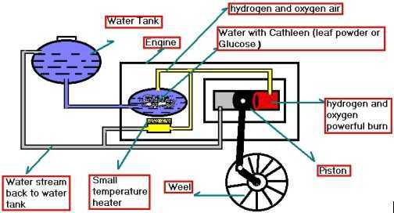

But I don’t want to talk about colonization problem creating by UK.

And also mentioned that that water taste is sweet and doesn't exist on earth. Yes that water is sweet because that water has Glucose and that water won't exist on earth because that water split as Hydrogen and oxygen and mix in to air but that Glucose will be left on earth. Glucose also called CATALYST
check this web site: http://witcombe.sbc.edu/water/chemistryelectrolysis.html
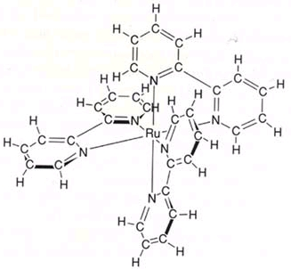
2H2O + CATALYST+ energy = 2H2 + O2 + CATALYST
You can make CATALYST Artificially or you can find from Nature say from leafs from tree. When tree have excessive CATALYST it omits from leaf or keeps in leaf. So CATALYST and water are reusable just need to add little water. I know what is that leaf. I just imagining about oil well, oil transporting, Gas stations, cost of goods transportation, Middle East problems.

Today two cops met me one is male one female. He came in side and stayed little time and said I can’t stay here because of dirty smoke and went outside. But female cop did her duty very well. She searched all and she didn’t care anything. She observed lot of things in my apt. I was watching both. Male cop standing out side. I gave him bunch of papers he didn’t concentrated on papers. But she read almost 30% of my papers. She did good job. When he talking about Kalki his behavior was not appreciable. I asked him simple question if anything happens to US what way you react for US. He was using words like superman save USA. I changed my face to female and asked simple question and she answered well. She is good cop. Fool bible say Jesus takes birth before end of world. He is nothing but Kalki. Jesus was saint he was not god. He was very poor with dirty cloth. He served people. What made male cop show different expression? . Jesus never take birth in western countries because if Jesus takes birth in western countries, one of person from people ask question that Hey Jesus your mom had many boy friends before your father marry her and your father had many girlfriends before marry same as you grand parents because USA is free sex county. So If he ask simple question who is your real Dad? Then Jesus won’t have answer for that question. So Jesus comes from east where family fallows one pair for life. Got Dirty White trash. I ask that Male cop who is your real grand father. Can he answer?

For many years many people trying to guess that where Abraham born, the answer is he was from India. I have proof. Abraham didn’t had kind at the age of 100, Abraham had 100 wifes (from different countries) to produce many kids that meant for Muslim Jews, Christens. Only Muslim Jews, Christens fight each other in world not Hindus. That is the reason god said end of world for Muslim Jews, Christens holy books not for Hindu holy book.

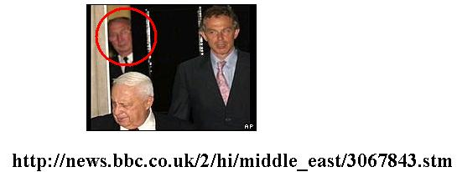
Who is middleman? his face look like controlling both faces. What is the purpose to attend Dinner party? Why Tony and Sharon got smashed after coming from door. You can kidnap one person to know truth. I believe he knows about 9/11 and what they planned in Dinner Party. Don’t try to put Bush picture next to Kennedy.

Please Note: Above information passed to Livermore police but not below information

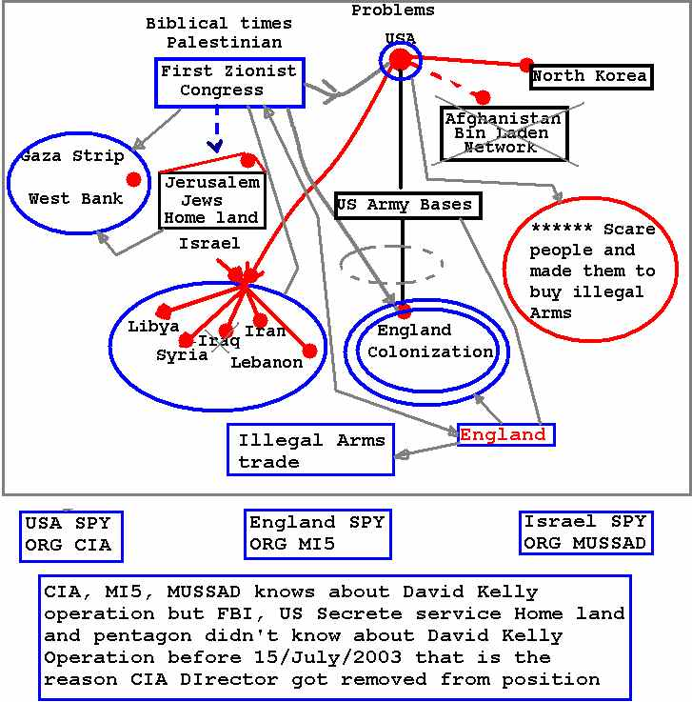
****
(That is the reason US secrete service increased heavy security for Bush after 17/July/2033, all time especially when Bush went to England first and last time after 17/july/2003. US and India political statements improved after 17/July/2003. CIA, MI5, MUSSAD knows about David Kelly operation but FBI, US Secrete service, Home land and pentagon didn't know about David Kelly Operation before 15/July/2003 that is the reason CIA Director got removed from his position)

